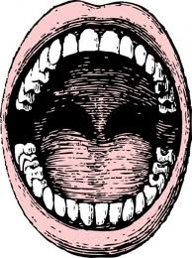
International Phonetic Alphabet (Simplified Version)
Vowels and Diphthongs
iy as in tree /triy/
ɪ as in insect /ɪnsɛkt/
ɛ as in bet /bɛt/
æ as in cat /kæt/
ɑ as in hot /hɑt/
ʊ as in foot /fʊt/
uw as in boot /buwt/
ə as in ago /əgow/ Remember, this is our friend, "schwa!"--most common vowel
ey as in play /pley/
ow as in know /now/
ay as in sky /skay/
aw as in how /haw/
oy as in boy /boy/
Consonants
p as in pop /pɑp/
b as in bit /bɪt/
t as in ton /tən/
d as in dog /dɑg/
k as in cat /kæt/
g as in gum /gəm/
tʃ as in chin /tʃɪn/
dʒ as in just /dʒəst/
f as in fine /fayn/
v as in vote /vowt/
θ as in thin /θɪn/
ð as in then /ðɪn/
s as in sick /sɪk/
z as in zoo /zuw/
ʃ as in shine /ʃayn/
ʒ as in vision /vɪʒən/
h as in heart /hɑrt/
m as in much /mətʃ/
n as in nice /nays/
ŋ as in thing /θɪŋ/
l as in leg /lɛg/
r as in read /riyd/ or /rɛd/
y as in yes /yɛs/
w as in wet /wɛt/

