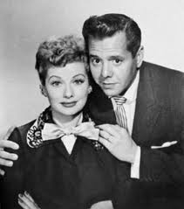
NAME: ____________ DATE: _________
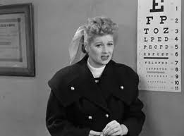
I Love Lucy, Episode #77
“Lucy Has Her Eyes Examined”
Unit 7 Review

- EVERYDAY VOCABULARY: Write the definitions of the following words.

- audition (v.)-
- phony (adj.)-
- folks (n.)-
- aspirations (n.)-
- bannister (n.)-
- splinter (n.)-
- alumni (n.)-
- blurred (adj.)-
- amateur (n. or adj.)-
- appealing (adj.)-

Pick 5 words from the list above that you are not very familiar with, and then use each one in a sentence that talks about the episode. Underline the vocab. word. EX: Lucy and her friends audition in front of Bill Parker.

1.
2.
3.
4.
5.

- SPECIAL VOCABULARY USED BY “KING CAT” WALSH, LUCY’S DANCE INSTRUCTOR: Write each definition. Note: These words were only used during the time period of the Jitterbug, which began in the late 1930s.

- the cat’s pajamas/the snake’s hips—a behavior that is admirable
- a gasser-something that is impressive
- cats-another word for “people”
- real wiggy-really wild and exciting
- chick-a girl or young woman (This is the only word that is still used today.)

- FUNNY DIALOGUES/PHRASES: Explain why each is funny.

- Bill Parker (to Ricky regarding show business): “Has your wife got aspirations?”
Ricky’s answer: “No, no, she’s feeling alright.”

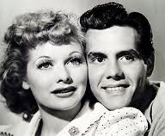
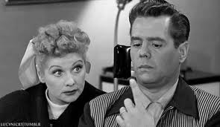
“Lucy Has Her Eyes Examined”—Page 2

- Ethel (to Fred after they finally found each other): “…Be sure and sandpaper that new bannister you put in before some idiot runs his hand down it and picks up a splinter. What were you going to ask?”
Fred’s reply: “I was wondering if you’d help me get this splinter out of my hand.”

- USING THE PAST PERFECT TENSE: Circle the correct form of the tense in parentheses.

- Lucy had trouble dancing in front of the audience at The Tropicana because the eye doctor (put, had put, have put) drops in her eyes.
- Lucy (had wanted, wants, want) to be in show business long before William Parker came over to her house for dinner.
- At the time he met Lucy, “King Cat” Walsh (learned, has learned, had learned) many unusual vocabulary words.
- When Mr. Parker first mentioned doing the Jitterbug dance, Lucy never (had danced, dances, dance) it before.
- When Mr. Parker (asks, had asked, is asking) Ricky if Lucy had aspirations for show business, Ricky misunderstood.

- DISCUSSING THE CONTENT: In pairs, interview each other using the following questions. Write your own answers to half of them, and take notes on your partner’s answers to the other half.
Partner A:
- What big risk did Lucy take in this episode? How did it turn out?

- What risk was Bill Parker undertaking in the show?

- What was the funniest part of this episode?

Partner B:
- Why did Lucy get rid of Ricky when Mr. Parker first came over for dinner?

- What was your opinion of “King Cat” Walsh? Why?

- How is I Love Lucy different from modern American T.V. shows?

