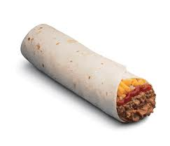
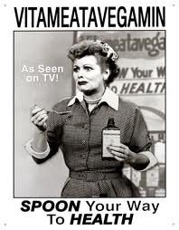
E. Pierce

ENSL B21 Presentation #2
Food Commercial (to be done individually)

Basic Description of Assignment:

Your job is to create your own commercial to advertise a food item of your choice. The ultimate goal is to convince your audience (our class) to purchase and consume whatever type of food you are advertising. To be truly convincing, you must use as many descriptive adjectives as possible as well as use an attention-getting prop.

Specific Elements of Assignment:

- Use “I Love Lucy” clip of vitameatavegamin advertisement as a perfect example of a great commercial. It is creative, humorous, persuasive, and contains effective vocabulary. *See attached script for this commercial.
- You must start your commercial with an attention-getting question, such as: Hello, all you people out there! Have you ever sunk your teeth into a crisp, crunchy, juicy apple?
- Your commercial can emphasize either your food’s taste OR its nutrition OR both aspects.
- You can select a basic food staple (like a carrot, banana, milk, etc.) or choose a prepared food (American-style or one that is unique to your country) or even advertise a vitamin supplement (like the one on “I Love Lucy”). It is fine to give your food a brand name (well-known or one that you create).
- 1 prop is required to enhance your commercial (of course, you can use more than 1 prop if you wish). Examples of appropriate props include: (1) any sort of object (ex. a fake piece of fruit), (2) a large picture on a poster board or PowerPoint slide (ex. a picture of a very healthy, attractive-looking person if you were advertising a nutritious product like whole wheat bread), (3) a sound clip or audio file (ex. instrumental music from a popular movie to play in the background while you present your commercial), or (4) any unusual item of clothing (not skimpy, however) to catch the audience’s attention (exs. funny wig, hat, shoes, t-shirt, etc.) If you want to use any other sort of enhancement or are not sure if your idea is acceptable, check with me first.
- Length of commercial: 1-2 minutes

How You Will Be Graded:

- How persuasive is your commercial? Did it make the audience truly desire
the food being advertised? ___/20 pts.
- Did you use numerous adjectives to adequately describe your product?
- ___/20 pts.
- Did you use a strong attention-getter at the beginning? ___/20 pts.
- Was your prop creative, and did it enhance your commercial? ___/20 pts.
- Was your speaking style effective (clear pronunciation, loud voice, enthusiastic tone, hand gestures, etc.)? ___/20 pts.

ENSL B21 Presentation #2
Food Commercial (continued)

Example of Funny Commercial (as performed by Lucy Ricardo in her commercial for the product Vitameatavegamin):

Here is the authentic Vitameatavegamin script (effective vocabulary words are bolded):
Hello, friends!
I'm your Vitameatavegamin girl.
Are you tired, run-down, listless?
Do you poop out at parties?
Are you unpopular?
The answer to all your problems is in this little bottle.
Vita-meata-vegamin.
Yes, Vitameatavegamin contains:
Vitamins,
Meat,
Vegetables,
and Minerals.
Yes, with Vitameatavegamin, you can spoon your way to health.
All you do is take a great big tablespoonful after every meal.
Mmmmmmm.....
It's so tasty, too!
Tastes just like candy!
So why don't you join all the thousands of happy, peppy people and get a great big bottle of Vitameatavegamin tomorrow!
That's Vita-meata-vegamin! (wink)

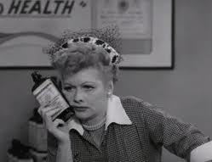
Source(s):
http://www.jitterbuzz.com/lucystuf.html
