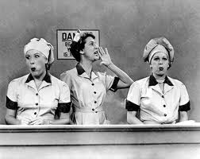
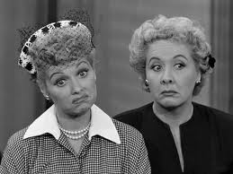
“Job Switching”—Page 2
(continued)

Interesting Expressions (cont’d):
6. bringing home the bacon Does this mean bringing a pig home? Explain.

III. Stress on Important Words (corresponds with p. 56 of our text): Fill in the blanks with the correct stressed words that you hear during the episode.
- Lucy when she sees the breakfast that she thinks Ricky has prepared for her: Well, doesn’t this look ________________!!
- The man working at the employment agency after he became very frustrated with Lucy’s answers: Now, what _____ you do?
- Ricky to Fred about ironing silk stockings (pantyhose): Fred, ______
knows that!

IV. Comprehension Questions Related to Unit 3 Theme of Success vs. Failure: Decide if you want to be Partner A or Partner B. Then ask your set of questions to your partner, taking notes on your partner’s answers.

Partner A’s Questions:
- What were Lucy and Ethel successful at doing?

- How did Lucy and Ethel fail? What did they learn from their failure?

- In your opinion, what is the message of the episode concerning the roles of men vs. women in society?

Partner B’s Questions:
- What were Ricky and Fred successful at doing?

- How did Ricky and Fred fail? What did they learn from their failure?

- How are the responsibilities of men/women in modern American society different from the era of I Love Lucy? Do you agree with this change? Why or why not?
- VOCABULARY: Listen for the following words. Try to write down the name of the speaker (ex. Lucy, Ricky, Fred, Ethel, or man, woman, etc.)

overdrawn:
creases:
scorch:
natural-born:
sensational:
specialty:
blabbing:
splendidly:
globs:
luscious:

- INTERESTING PHRASES/EXPRESSIONS: Many of these are idioms that are commonly used in everyday English.

- Fred talking about Ethel: She spends money like I was printing it in the
basement. What do you think Fred means by this?

- Cut that out! If someone says this to you, what is the actual meaning?

- To pool our talents Explain what you think this means.

- The lady in charge at the candy making shop: Let her roll! What was she referring to?

- Fred to Ricky: Well, I had it thrown at me on one of the darkest days of
my life! What does Fred mean when he says “it”? (Hint: This is related to a common American wedding custom.)

ENSL B21, Unit 3: Success and Failure
as illustrated in Episode #39
“JOB SWITCHING”

