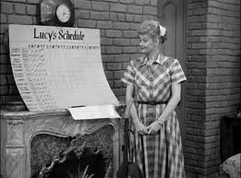
ENSL B21, Unit 4 Review
“Lucy’s Schedule”
Season 1, Episode #33

- VOCABULARY: Write down the meanings of the following words that you will hear during the episode.

- persist (v.)
- tardiness (n.)
- masterpiece (n.)
- globs (n.)
- tender (adj.)
- punctuality (n.)
- ogre (n.)
- formality (n.)
- brainstorm (v.)
10.appetite (n.)

- SPECIAL PHRASES: Rewrite each underlined part in your own words.

- Lucy to Ricky regarding which dress to wear to the movies: “I can’t make up my mind.”

- Ricky laid down the law by putting Lucy on a schedule.

- Lucy was worried that if she spent too much time on one activity, it would throw her off her schedule.

- Ricky claims to Mr. Littlefield that he has taught Lucy “to jump around like a trained seal.”

- Mrs. Phoebe Littlefield explains to Lucy that if she demonstrates that the schedule works, she will louse it up for housewives everywhere.

- At the end, Mr. Littlefield tells Ricky that he has been cracking down too hard on Lucy, acting like a slave driver.

- SIMPLE PAST vs. PRESENT PERFECT (p. 76 of Unit 4): For each sentence, (1) identify which of the 2 tenses is used, and (2) explain why that particular tense is used.
Example: Ricky has put Lucy on a schedule. Present perfect
Ricky started Lucy on a schedule in the past, and it
continues in the present.
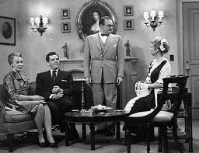
ENSL B21, Unit 4 Review
“Lucy’s Schedule”
Page 2

- Mrs. Littlefield has always liked the fake fruit on her table.

- Before the schedule, Lucy was often late to important events.

- After being put on a schedule, Lucy has learned to budget her time.

- CONTENT QUESTIONS: Ask a partner for the answers to ½ of the questions. Take notes on your partner’s answers. NOTE: Italicized/bolded words are taken from Unit 4 vocabulary.

Partner A:

- What was the change to which Lucy had to adapt in her life?

- Was the change good or bad? Why?

- Why did Ricky want Lucy to be on a schedule? What position was he hoping to get from Mr. Littlefield?

Partner B:
- In what ways did Lucy rebel against Ricky’s idea of putting her on a schedule?

- Why did the 3 women (Lucy, Ethel, & Phoebe) cooperate during the dinner?

- Do you think Ricky handles Lucy like a child? Why or why not?

