Module 3 Learning to Use Context Clues NAME: __________
ACDV 70F VOCABULARY
LAB #2
EDUCULTURE VOCABULARY DEVELOPMENT DATE: ___________

Slide 5 Examples of Direct Definition

Draw a circle around the synonym or phrase which directly defines the italicized word in each sentence.

- He was very impudent, absolutely rude to his mother.
- Psychology, the study of the mind and behavior, is a required course at many colleges.
- Parapsychology, that is, the branch of psychology that deals with the investigation of psychic phenomena such as telepathy, ESP, and the like, is being given serious attention by universities these days.
- He was most vociferous, extremely noisy in his objections.
- A bird sanctuary is a place where birds can breed and take refuge from hunters.

Slide 7 Recognizing and Using Signal Clues

Circle the “signal clues,” and define the indicated word in the sentences below.

- The statutes, laws, regulations, and customs in this city are out of date.
statutes means ________________________________________

- In philosophy, automatism is the doctrine which states that all activities are controlled by physical causes.
automatism means ______________________________________

- The repairman brought a weird conglomeration of tools, that is, an assortment of funny-looking gadgets and small machines that we had never seen before.
conglomeration means ___________________________________

ACDV 70F Vocabulary Lab #2 (continued)

- Immediate restitution, the restoring or paying back for losses, should be made to the victims of the swindle now.
restitution means ______________________________________

Slides 8-10
Slide 12

- ________
- ________
- ________
- ________
- ________

- ________
- ________
- ________
- ________
- ________
- ________
- ________
Slides 15-16,
REVIEW: TOPIC 1

PART ONE PART TWO

- _____ 1. ________
- _____ ___________
- _____ ___________
- _____ ___________
- _____ ___________
- _____
- _____ 2. ________
- _____ ___________
- _____ ___________
- _____ ___________

- ________
Slides 13-14

- a. candor means: _________________
b. signal clue: ___________________
- a. lucid means: __________________
b. signal clue: ___________________
- a. plaintiff means: ________________
b. signal clue: ___________________
- a. plaintive means: ________________
b. signal clue: ___________________
- best definition for association: a. b. OR c.
- best definition for intrusion: a. b. OR c.

- ________
Slides 17-18
EXAMPLE A:
placid and calm = _______________________
raging and placid = ______________________
EXAMPLE B:
plausible and believable = _________________
plausible and unbelievable = ________________
EXAMPLE C:
tranquil and a state of mental confusion = _______________________________

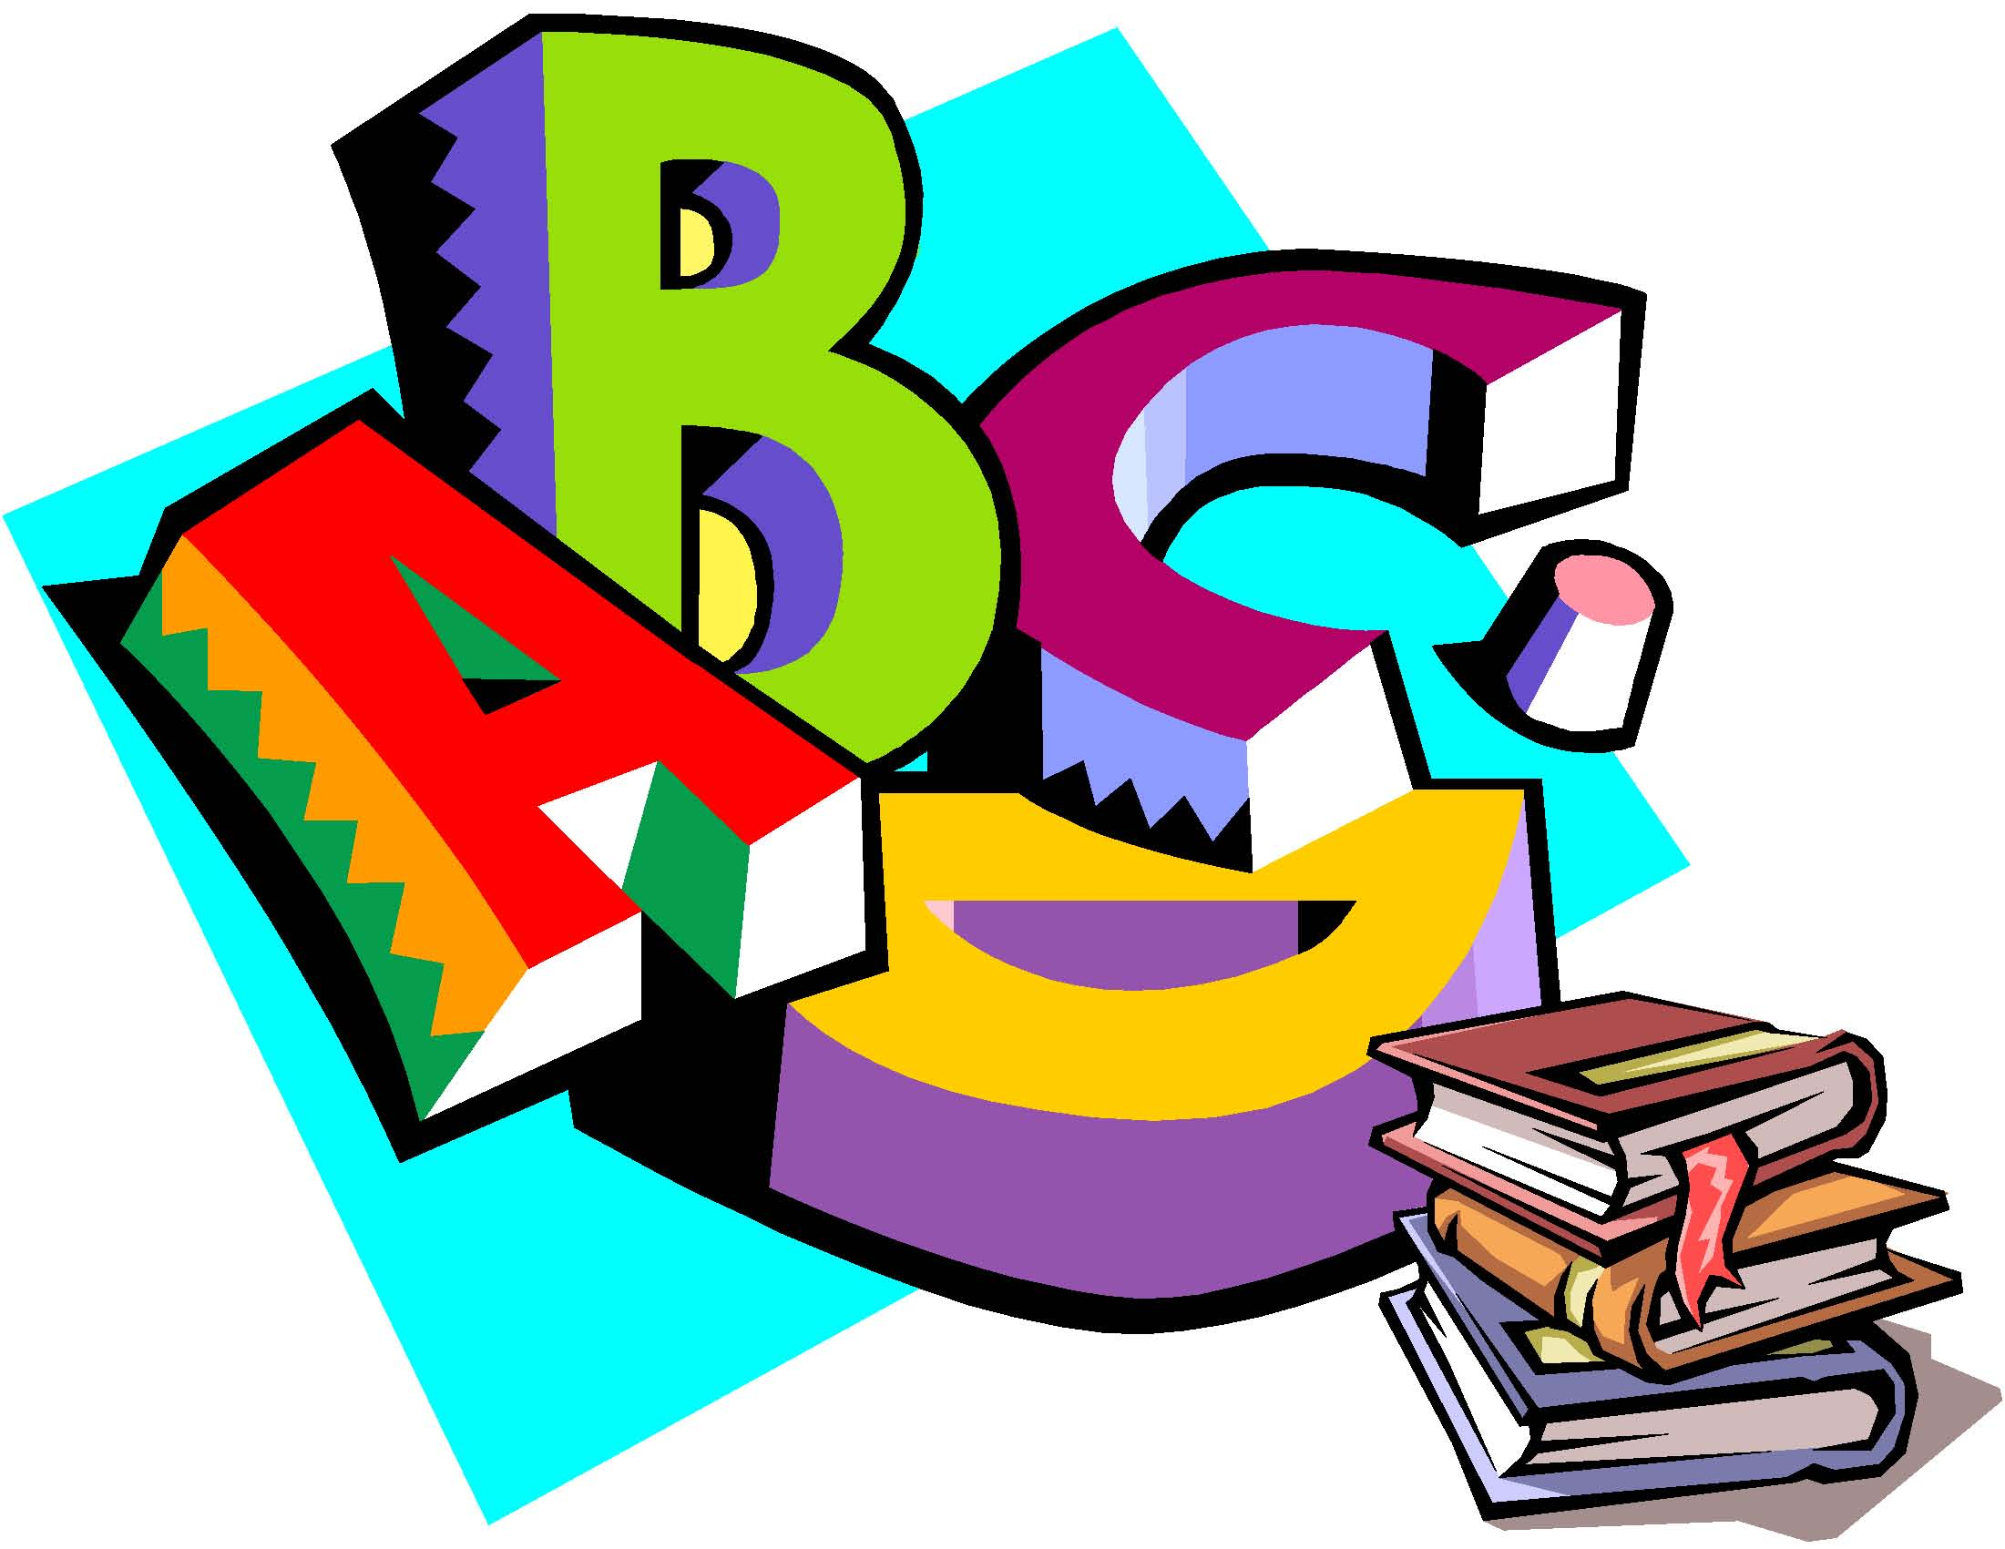

ACDV 70F Vocabulary Lab #2 (continued)

ACDV 70F Vocabulary Lab #2 (continued)

Slide 20 Examples of Indirect Definition

Circle the antonym or phrase that indirectly helps define the underlined word.

- While the peasants were filled with exultation over the military takeover, the king felt nothing but grief.
- Although he tried to ascertain the possible hazards involved in the job,
he could not possibly determine what was in store for him.
- Her speech continued throughout in a monotone. Someone should tell her to vary the tone of her voice.
- Even though the mountain trail was precarious, he felt certain he could
conquer it.

Slides 22-23 Recognizing Contrasting Signal Clues

Circle all the turnabout words. Then write the definition of the underlined word in the blanks provided.

- Although he enthusiastically aspired to be a football player, he never qualified for the high school team.
aspired means________________________________________
- Despite being babied by his mother, he turned out to be a self-reliant person.
self-reliant means_____________________________________
- Although she seemed capable of vanquishing all her opponents, her losses in competition were quick and decisive.
vanquishing means_____________________________________
- While the meaty foods she prepared were nutritious enough for her dog, my health demanded more variety.
nutritious means______________________________________
- She usually greets me with fervor; however, yesterday she seemed rather cool.
fervor means_________________________________________

Slides 24-27
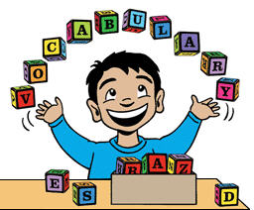
1a. potent means:___________________
b. signal clue:_____________________
2a. wanton means:__________________
b. signal clue:_____________________
ACDV 70F Vocabulary Lab #2 (continued)

Slides 24-27 (continued)

3a. pensive means:__________________________________________
b. signal clue:____________________________________________
4a. abate means:___________________________________________
b. signal clue:_____________________________________________
5. best definition for derelict: a. b. OR c.
6. best definition for derelict: a. b. OR c.
7. best definition for derelict: a. b. OR c.

Slides 28-29 REVIEW: TOPIC 2

Looking at Slides 28-29, write down the word from the list provided at the top of each slide which means the same as the underlined words or phrases in each sentence. The first one has been done for you.

- plaintive 6. _____________________
- ____________________ 7. _____________________
- ____________________ 8. _____________________
- ____________________ 9. _____________________
- ____________________ 10. ____________________

Slide 30

EXAMPLE A:
Wary probably means: (Circle 1, 2, or 3 ).

EXAMPLE B:
Enticed probably means: (Circle 1, 2, or 3).

Slides 31-33

- foiled means:_______________________________________
- satiate means:______________________________________
- insatiable means:_____________________________________
- reproach means:______________________________________
- lament means:_______________________________________
- a. The spy wanted to keep his meetings a __________________.
ACDV 70F Vocabulary Lab #2 (continued)

Slides 31-33 (continued)

b. A secret meeting is often called ______________________.
- A synonym for impound is _____________________________.
- Impending means: ___________________________________
- Circle the best definition for board: a. b. OR c.
- Circle the best definition for board: a. b. OR c.
- Circle the best definition for board: a. b. OR c.

Slides 34-35

- __________________________________________________
- __________________________________________________
- __________________________________________________
- __________________________________________________
- __________________________________________________
- __________________________________________________
- __________________________________________________
- Give three definitions for board:
- ________________________________________________
- ________________________________________________
- ________________________________________________
- Give three definitions for cross:
- ________________________________________________
- ________________________________________________
- ________________________________________________

Slides 36-37

EXAMPLE 1: atrophied means ______________________________
example clues _______________________________

EXAMPLE 2: epithets are _________________________________
example clues _______________________________

ACDV 70F Vocabulary Lab #2 (continued)

Slides 38-42

1a. augment means __________________________________________
b. example clues __________________________________________
2a. enhance means __________________________________________
b. example clues __________________________________________
3a. avarice means __________________________________________
b. example clues __________________________________________
4a. dexterity means _________________________________________
b. example clues __________________________________________
5a. impeccable means _______________________________________
b. example clues __________________________________________
6a. acute means ___________________________________________
b. example clues __________________________________________
7a. discordant means ________________________________________
b. example clues __________________________________________
8a. reticence means _________________________________________
b. example clues __________________________________________
9a. subtle means ___________________________________________
b. example clues __________________________________________
10a. subtle means __________________________________________
b. example clues __________________________________________

Slides 43-45

Circle the letter which best explains what the word means.

1. atrophied a. b. c. 6. dexterity a. b. c.
2. epithets a. b. c. 7. impeccable a. b. c.
3. augment a. b. c. 8. discordant a. b. c.
4. enhance a. b. c. 9. reticence a. b. c.
5. avarice a. b. c.

Only 2 more
pages to go!

ACDV 70F Vocabulary Lab #2 (continued)

Slide 46 Personal Experience Clues

/A. Would you touch this? B. Would you drink this? C.Would you handle this?

Yes ____ No ____ Yes ____ No ____ Yes ____ No ____
Because __________ Because __________ Because ____________
________________ ________________ __________________
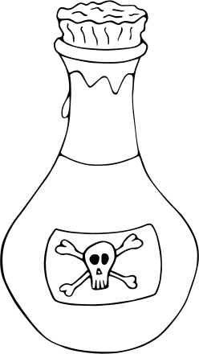
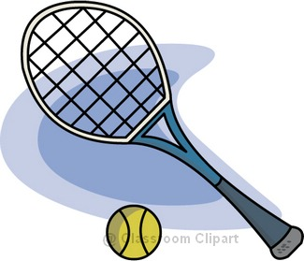
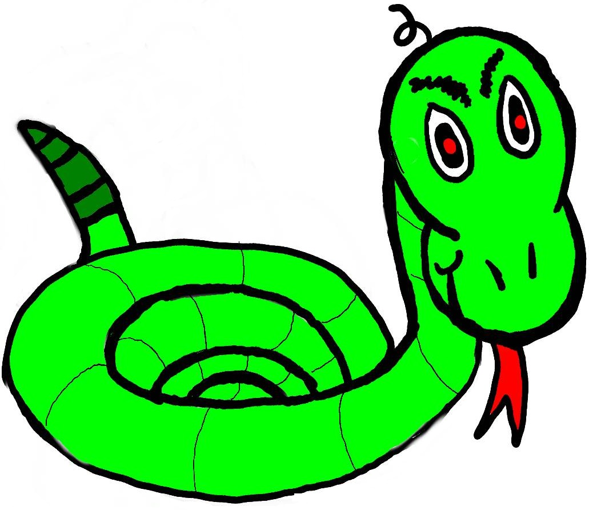

Slide 47

EXAMPLE A: flaccid means ____________________________________
EXAMPLE B: copious means ____________________________________

Slides 48-52

- languid means ________________________________________ experience clue _______________________________________
- interminable means _____________________________________
experience clue ________________________________________
- odious means __________________________________________ experience clue ________________________________________
- vindictive means _______________________________________
experience clue ________________________________________
- vulnerable means _______________________________________ experience clue ________________________________________
- impression means _______________________________________
experience clue ________________________________________
- impressions means ______________________________________ experience clue ________________________________________
- idle means ___________________________________________
experience clue ________________________________________
ACDV 70F Vocabulary Lab #2 (continued)

- idle means ___________________________________________ experience clue________________________________________
- idled means ___________________________________________
experience clue ________________________________________

Slides 53-54

1. _______________________ 6. _________________________
2. _______________________ 7. _________________________
3. _______________________ 8. _________________________
4. _______________________ 9. a. _______________________
5. _______________________ b. _______________________
c. _______________________
10. _________________________

Slide 55 Summary of the Five Methods Studied

METHOD 1 ________________________________________________
METHOD 2 ________________________________________________
METHOD 3 ________________________________________________
METHOD 4 ________________________________________________
METHOD 5 ________________________________________________
/
7. tenacity means _____________
adversity means_____________
8. x. y. OR z.
Match the letter of the best defi-
nition to the sentences given.
Hint: 1 letter is used twice!
- ________ c. __________
- ________ d. __________
9. (same directions as for #8)
x. y. OR z.
a. ________ c. __________
b. ________ d. __________
10. terminate means ___________
Slides 56-61 Module Review
PART ONE
- vociferous means _________________
- prominent means _________________
- erratic means ___________________
- exorbitant means ________________
- inane means ____________________
- /sanction means __________________
contempt means _________________
Slide 62 Module Review
PART TWO
1. _____ 4. _____ 7. _____ 10. _____
2. _____ 5. _____ 8. _____
3. _____ 6. _____ 9. _____

//
/

Answers to slides are provided
in slides 65-85 of this Power-
Point.
Slides 63-64 Module Review
PART THREE
1. a. b. c. 3. a. b. c. 5. a. b. c.
2. a. b. c. 4. a. b. c. 6. a. b. c.

